Application of GIS Analysis to Obtain Anisotropic Bicycle Catchment Areas with Level of Traffic Stress (LTS) and Energy Consumption

July 31, 2019

Devin McNally
Candidate in the Master of Community Planning; email: devinm@umd.edu
Urban Studies and Planning (URSP) Program

Rachel Tillinghast
Candidate in the Master of Community Planning; email: rtilling@umd.edu
Urban Studies and Planning (URSP) Program

Hiroyuki Iseki, Ph.D.
Associate Professor; e-mail: hiseki@umd.edu
Urban Studies and Planning (URSP) Program
National Center for Smart Growth Research and Education

School of Architecture, Planning & Preservation
(Maryland’s Built Environment School)
University of Maryland, College Park
1112K Preinkert Field House, College Park, MD 20742
Phone: 301-405-4403; Fax: 301-314-5639

Abstract (213 words)

Bikeability has become an important component of planning strategies as smart growth concepts grow in popularity. Transportation planners are increasingly required to conduct complex analyses to provide supporting evidence for proposed plans and communicate well with both decision makesr and the public. Cyclists experience two important factors on roads: (a) travel stress related to the built environment and (b) changes in physical burden due to topography. This study develops a method that integrates an energy consumption calculation and “bicycling stress” score to take into account external conditions that influences cyclists substantially. While the level of traffic stress (LTS) is used to select street segments appropriate for different comfort levels among cyclists, biking energy consumption, in addition to distance, is used as travel impedance to take into account the effects of slopes and street intersections. The integrated Geographic Information System (GIS) analysis methods are used to evaluate bicycle infrastructure improvements in coming years in Montgomery County, Maryland in the USA. The analysis results demonstrated that the infrastructure improvements in the county’s bike master plan are well-targeted to improve bicycling accessibility. Furthermore, the use of energy as opposed to distance to generate bikeshed areas results in reduced areas. The method presented herein allows planners to characterize and quantify the impact of bicycle infrastructure and prioritize locations for improvements.

Introduction

Bicycle planning has become an important part of local transportation planning in urbanized areas in the US. In that context, Geographic Information System (GIS) is used in a variety of tasks, ranging from simple mapping to advanced analysis. Examples include understanding factors influencing mode choice (Dill & Voros, 2006), mapping the location and quality of bicycle infrastructure to identify areas of high and low bikeability (Greenstein, 2015), and using vector data to understand the connectivity of the bicycle network (Mekuria, et al., 2012). GIS analyses allows for better understanding of where bicycle infrastructure needs exist and how they should be prioritized.

The Montgomery Planning Office in Montgomery County, Maryland has developed GIS analyses for use in their Bicycle Master Plan and future bicycle infrastructure planning (Montgomery County, No Date). Montgomery County’s bicycle accessibility model allows analysts to impose constraints on the bicycle network by removing segments with a level of traffic stress (LTS) exceeding a certain tolerance from the traversable network. The Planning Office utilizes the LTS method in a variety of GIS analysis including prioritization of proposed infrastructure, identification of gaps in the existing network, and minimization of travel along higher-stress streets. Transportation planners slightly modified the LTS proposed by Mekuria, et al., (2012) which accounts for the level of safety perceived by existing and potential cyclists who have different levels of tolerance regarding risk and stress in biking. This method classifies streets by number of vehicle traffic lanes, traffic speed, and attributes of bicycle infrastructure. The modified LTS method employed by the Planning department is slightly more nuanced to accommodate local variations in the road network in Montgomery County.

The study presented here integrates an energy consumption method proposed by Iseki and Tingstrom (2014) with the Montgomery County LTS GIS analysis. The integrated method allows for the delineation of bicycle catchment areas (bikesheds) using biking energy consumption as a travel impedance and LTS values as a traversability restriction. Utilizing energy consumption enables analysts to consider elevation change by incorporating effort, or energy, required to complete the trip as a variable expressed in joules. Using this energy consumption impedance, a bike accessibility analysis was conducted with metro stations and high schools as trip origins. Although the importance of topography has been noted in other studies, few have incorporated elevation change into analyses and none have combined energy consumption with an evaluation of the quality of the bicycle network as provided by the LTS method.

The analyses findings indicate that County planned bicycle improvements are well targeted to increase multi-modal transportation options and accessibility to significant community assets. The energy consumption model for bikesheds may, however, prove useful in refining the locations of proposed bicycle infrastructure improvements.

This study will highlight recent literature on GIS analyses in bicycle planning, energy consumption methods, and LTS methods. A summary of data sources and methods used in this study will then be discussed, followed by analysis results. The conclusion will include a brief summary of findings, limitations to be addressed, and planning implications.

The model presented herein is introduced as an alternative method to traditional distance methods, which fail to take topography into account when assessing accessibility. Combining these methods with an index of biking stress level allows for a more nuanced understanding of accessibility and of the characteristics relevant to creating successful transportation networks. The energy consumption model detailed in this paper is of particular interest to planning practitioners, as it contributes to current issues faced in the field.

2. Literature Review

In recent practice, transportation planners have increasingly incorporated a number of variables in GIS analysis to more accurately reflect current conditions in bike infrastructure, the built environment, and traffic conditions. These variables have been incorporated to more accurately describe and understand the motivations of cyclists, gaps in bike networks, and the location of priority service areas in order to implement multi-modal transportation systems. Studies increasingly acknowledge the complex social, economic, and environmental impacts of mobility, but some argue that these tools and methods are limited in their ability to accurately describe the characteristics of bicycle infrastructure (Necessary, 2016).

Studies on bicycle accessibility tend to identify similar factors that encourage or discourage biking. Conceptually, these factors are considered to lower generalized costs of biking, so that biking becomes a more viable alternative to other modes of travel. The range of factors consistently given the highest weight in recent literature are associated with existing bicycle infrastructure. This includes protected and unprotected bicycle lanes, trails, signage, and other features meant to reduce the stress of cyclists through perceived or actual safety (Greenstein, 2015). In an Austin bikeability study, bicycling stress was assigned the highest weight amongst other variables, in congruence with studies conducted in Portland, Seattle, and Vancouver (Greenstein, 2015). These studies agree that perceived safety is a primary factor for inducing more bicycle trips.

Another factor consistently mentioned in studies on biking is the street network itself. As Greenstein (2015) notes in her analysis, “As connectivity increases, travel distances decrease and route options increase”. A street network with more connections allows cyclists to choose a route which avoids streets with heavy traffic, substandard bicycle infrastructure, or significant changes in elevation. In assessing network connectivity, studies frequently include measures of infrastructure and conclude they are one of the most important factors in increasing the appeal and ease of biking. (Parast 2010; Geller, et al. 2008; Cervero & Duncan, 2006; Reilly & Landis, 2002; Winters & Cooper, 2008).

Level of traffic stress and level of service methods have been proposed for evaluating bicycling stress. Level of service (LOS) methods rely on street designations defined by user level of satisfaction. While both methods assign roads scores, LOS adds a level of detail beyond simply using bicycle facilities and traffic speed. In practice, this has been accomplished through video surveys and field rides (Foster, et al., 2015; Jensen, 2007) as well as mathematical approaches which quantify perceptions of satisfaction (Foster, 2014; Okon, et al., 2017). The LTS method is preferred in use because it is typically less data-intensive than LOS.

The influence of slope and of elevation on bicycling are points of contention. While slope has not been statistically proven to influence cycling (Cervero & Duncan 2003; Dill & Voros, 2006), Cervero and Duncan (2003) utilized discrete-choice logit modeling to identify a correlation between walking and slope. They remark that there are likely similarities between the two travel modes. Other studies have included slope as a variable, but provided it with a lower weight than other factors, such as bicycle infrastructure and network connectivity (Greenstein, 2015). However, differences in rider profiles (recreational and commuting, for example) may account for the differences in results (Greenstein, 2015). Macias (2016) also found that incorporating infrastructure characteristics has a greater impact on the size of pedestrian catchment areas than do changes in elevation.

One common method of capturing the “maximum travel cost” pedestrians or cyclists are willing to spend is by producing catchment areas, traditionally based on euclidean distance (Macias 2016). Iseki and Tingstrom’s study (2014) demonstrates a new method of calculating bikesheds by incorporating slope and using energy as an impedance value instead of distance. The method attributes values to road segments based on the energy required to traverse them, calculated from a function of the speed of the cyclist, the distance of the segment, wind resistance, tire resistance, and the slope of the road segment. The paper demonstrates that this method can incorporate both slope and the road network to generate a detailed bicycle catchment area.

Following with trends to identify interconnecting factors impacting bike transit, Macias (2016) found that conventional methods of determining catchment areas “can misjudge factors that are important in determining walkability and transit-oriented development”. Distance-calculated bikesheds illustrate network connectivity without expressing other infrastructure characteristics (Necessary 2016), and do not adequately describe accessibility. Researchers have begun recognizing the importance of topography and incorporating it into the creation of pedestrian catchment areas. Consistently, this new method has been found to produce smaller areas (Macias, 2016; Daniel & Burns, 2018), regardless of differences in impedance calculation. While Macias (2016) calculated average slope and pedestrian power values, Daniel and Burns (2018) used time as impedance.

Although the importance of topography and traffic stress have been noted in the aforementioned studies, none have combined energy consumption with an LTS method to the best of our knowledge. A method of developing bicycle catchment areas is necessary to inform bicycle infrastructure and illustrate characteristics influencing biking access. Most studies on bikeability use raster analysis, aggregating the factors of bikeability in a specified area. This method cannot isolate the impact of individual improvements (Greenstein, 2015; Parast, 2010). Combining LTS with Iseki and Tingstrom’s method enables planners to evaluate the impact of infrastructure improvements and quantify the accessibility of destinations.

3. Description of Study: Study Area, Data, Data Sources, and analytical methods

This study enhances the existing model capability by incorporating consideration of topography and demonstrating how the results from the distance and energy consumption methods differ. In this study, we worked with the planning office of Montgomery County, Maryland to complete an accessibility analysis for bike planning.

Montgomery County is located adjacent to Washington, D.C. and is among the most populous and affluent counties in the state of Maryland. It has several large population centers, with density primarily located along the Interstate 270 corridor leading to the nation’s capital. In 2018, the county developed a Bicycle Master Plan with the goal of enabling bicycling to become a viable transportation option and creating a “world-class bicycling community” (Maryland-National Park and Planning Commission: Montgomery County, 2018).

For the creation of their Bicycle Master Plan, the county relied on research from a consultant to classify high rates of bicycling, low rates of bicycle crashes, and high levels of satisfaction with bicycling conditions as the necessary components of a “world-class” bicycling network. In pursuance of these goals, the county established three elements for their plan: safety, comfort, and connectivity. To identify necessary changes to the existing infrastructure, the county conducted its own LTS analyses. Bikeways were prioritized through a demand model that relied on information from the LTS network and the percentage of dwelling units located on low-stress roads within 2 miles of key destinations. The county also created a matrix of trips likely to generate the most bicycling based on clusters of homes and jobs, proximity to key destinations, and connectivity between activity hubs.

Data and Data Sources:

Shapefiles for Montgomery County Metro Stations, Purple Line Stations, Public High Schools, and Capital Bikeshare Stations were obtained from the Montgomery County GIS Open Data site. Elevation data was obtained from the 3D Elevation Program (3DEP) of the United States Geological Survey (USGS). Bicycle network GIS files were originally provided by the Montgomery County Planning Office for this study. The network included centerline data and characteristics of each road segment with the current infrastructure’s LTS and planned LTS after the construction of new infrastructure under their BMP (hereafter referred to as existing and planned infrastructure). The BMP proposes extensive improvement projects including the addition of bikeable shoulders, neighborhood connectors, neighborhood greenways, off-street trails, priority shared lane markings, separated bicycle lanes, and sidepaths. It identifies more than half of these proposed improvements as new infrastructure (Maryland-National Park and Planning Commission: Montgomery County, 2018).

Analytical Methods:

The variables for bicycle infrastructure and perceived safety used in this study were the LTS values assigned to each road by the Montgomery County Planning Department. As a part of Montgomery County’s BMP, street segments were assigned a level of stress value related to proximal traffic and bicycle infrastructure, based on the method proposed by Mekuria, et al. (2012). The method assigns a numeric LTS value (1, 2, 3, or 4) based on traffic attributes such as speed and volume, taking into account bicycle infrastructure (protected lanes, bikeable shoulders, bicycle only trails). A lower number indicates a lower level of stress( Maryland-National Park and Planning Commission: Montgomery County, 2018). The Montgomery County Planning Department revised the method to include three additional stress values - 0, 2.5, and 5 - in order to provide more nuance. LTS 0 identifies completely separated bicycling infrastructure, LTS 2.5 reduces the comfort gap between LTS 2 and LTS 3, and LTS 5 identifies roads with very high speed limits and little to no bicycle infrastructure. The department also modified some LTS value definitions based on their own assumptions (Maryland-National Park and Planning Commission: Montgomery County, 2018).

As the first step in calculating the level of energy consumption, the street network was divided into smaller segments using a 100 meter by 100 meter fishnet. Elevation was extracted to the start and end points of the line segments from USGS DEM elevation layers. These points were then used to calculate the actual length of the road segment, accounting for elevation change, and to calculate the slope for each line segment.

Using the method proposed by Iseki and Tingstrom (2014), an energy consumption value (in watts) was calculated for each line segment using the following equation, allowing for drag factor, velocity (4), rider mass, gravity, slope, tire resistance, and adjusted length:
Energy = ([0.245 * (4)² * 80 * 9.807 * (slope + 0.004)] * 4) * [adjustedlength/4]
This formula quantifies the energy required to traverse the road segment at a constant speed. After creating a network dataset, energy penalties for turns based on the street type (local, secondary, or primary) were created, also taken from the study by Iseki and Tingstrom.

Based on the assumption that people will not bike on street segments with an LTS higher than their tolerance level, the maximum LTS is selected for each run of analysis as restrictions in a path finding analysis. Because Montgomery County’s LTS index is comprised of seven values, the accessibility models in this analysis can display fourteen different scenarios based on the stress tolerance values selected and the method used.

The resulting bikesheds were limited at either 4.4 miles or 50,000 joules; the distance limit was proposed by Iseki and Tingstrom (2014) while the latter is its energy equivalent over flat terrain. Energy consumption was calculated to and from each location (as a trip destination and origin) to account for direction-dependent change in energy and the intersection of the resulting bikesheds were used for comparison with distance method bikesheds. The proposed model assumes an adult rider at 80kg which should be adjusted, together with distance/energy cutoffs, for younger riders.

The method proposed by Iseki and Tingstrom (2014) was the first to incorporate energy consumption into bicycle planning in 2014. Other studies that have used topography as a factor have used a raster analysis which weighted the average slope of an area, along with a variety of factors (Greenstein, 2015). This study considers LTS and topography for individual roads to generate a catchment area; rather than conducting a raster analysis of weighted scores. The results demonstrate a more granular view of bicycle accessibility.

4. Analysis Results

The developed method was applied to two types of bicycle accessibility analyses. The results showed that the energy consumption method generates significantly smaller bikesheds than those generated by the distance method. Furthermore, these results show that the planned improvements under the BMP of Montgomery County metro stations and public high schools, beginning at the least restrictive levels of stress. Metro stations’ low LTS bikeshed areas will grow between 864% and 2,003% as a result of the planned improvements and those of public high schools will increase between 817% and 1,590% at the none LTS.

Metro Station Bikeshed Scenario Analysis
Sixteen scenarios were created with Montgomery County metro stations as destinations. Each scenario was generated using either the distance or energy method (with cutoffs of 4.4 miles and 50,000 joules) and incorporates stress level index scores. Four different stress level scores, ranging from low (value of 2) to high (value of 5), were included. These values were chosen to demonstrate the differences in bikesheds based on rider profiles. Low (value of 2) represents the highest stress value accepted by novice cyclists while high (value of 5) represents the highest accepted stress value for most advanced cyclists. These four stress level index values were tested using both methods. Finally, current infrastructure was compared with planned infrastructure.

Figure 1 shows the results of the 16 scenarios and demonstrates that most metro stations are not currently very accessible. The total bikeable area around metro stations restricted to a low stress level (value equal to 2) is 2.7 square miles using the energy consumption method and 12.8 square miles using the distance method. One possible reason is the placement of metro stations. Two metro stations (White Flint and Silver Spring), among thirteen stations, were considered inaccessible by our model in the existing state because both are located along major roads with high stress level index scores. Other metro stations are proximal to major roads without dedicated bicycle lanes or alternative routes, limiting the area of their respective bikesheds.

Figure 1: Area of Bikeshed in Square Miles for LTS Values from Low to High (Score of 2 - 5)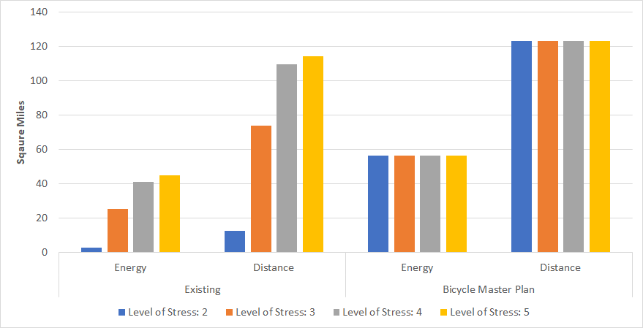

However, if the Bicycle Master Plan is fully implemented, the low stress accessibility of metro stations will increase dramatically. Table 1 and Figure 2 demonstrate large increases in the size of the bikeshed in both methods with an increase in bikeshed area of over 53 square miles using the energy consumption method and an increase of 110 square miles using the distance method for the lowest stress level (2).

In both methods, scenarios using the planned infrastructure improvement stress level values produce the same area. This indicates major upgrades along the most stressful roads. There appear to be significant proposed changes to existing infrastructure, such as the implementation of a new bicycle trail along an electric corridor and bicycle improvements along major, inter-county thoroughfares. These types of improvements allow for biking along primary connectors which previously had prohibitive LTS values. Gains decreased as the level of stress tolerance increased because most infrastructure improvements were directed at network segments with a high level of stress. The gains at the high level of stress are a result of new infrastructure, such as bike trails.

Table 1 shows the sizes of bikesheds obtained in 16 scenarios, depending on the allowable LTS and impedance method used, as well as the changes in bikeshed area and percentage from the current conditions to the planned state under the BMP. The change in the stress level scores for a large number of major roads results in large changes in the area of the bikesheds for both methods. The energy method has large changes in the size of the bikeshed, however, the size of energy bikesheds are still significantly smaller than bikesheds generated using the distance method.
Table 1: Change in Bikeshed Area from Existing to Planned Infrastructure by Percentage and Square Mileage
 | Percent Gain |  | Area Gain |  | Existing Total Area |  | BMP Total Area
 | Energy | Distance | Energy | Distance | Energy | Distance | Energy | Distance
Level of Stress: 2 | + 2,003% | + 864% | +53.98 mi² | +110.64 mi² | 2.70 mi² | 12.80 mi² | 56.68 mi² | 123.44 mi²
Level of Stress: 3 | + 123% | + 67% | +31.22 mi² | +49.53 mi² | 25.46 mi² | 73.91 mi² | 56.68 mi² | 123.44 mi²
Level of Stress: 4 | + 38% | + 13% | +15.73 mi² | +13.89 mi² | 40.95 mi² | 109.54mi² | 56.68 mi² | 123.44 mi²
Level of Stress: 5 | + 26% | + 8% | +11.80 mi² | +9.20 mi² | 44.87 mi² | 114.24 mi² | 56.68 mi² | 123.44 mi²

Figure 2: Comparison of Distance and Energy Methods: Existing vs Planned Infrastructure at a Low Stress Level
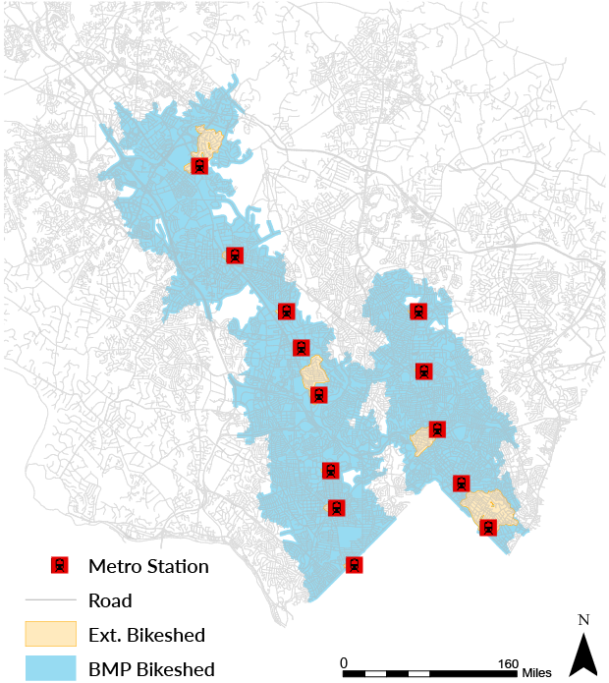 | 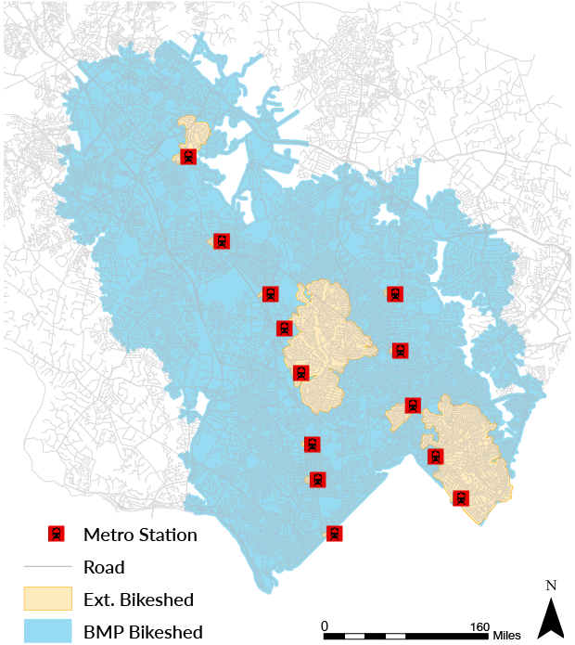

High School Accessibility: Bikeshed Scenario Analysis
Bikesheds were created at every level of stress for 25 of 26 Montgomery County public high schools as trip origins (excluding one vocational/technical high school without feeder schools). These were created for existing and planned bicycle infrastructure, using the distance (with a limit of 4.4 miles) and energy consumption methods (with a limit of 50,000 joules). As was found in the analysis of metro stations, the bikesheds with a 4.4-mile limit exceeded those with a 50,000 joule limit in area at every LTS.

Like the comparison of metro station bikesheds, biking accessibility to high schools with current infrastructure is limited and does not exceed 30 square miles county-wide until reaching a “moderate high” level of stress (LTS 3). As seen in Figure 3, the change in area is much more dramatic for distance-based bikesheds than for energy consumption-based bikesheds. This is related to significant elevation changes in the study area.

Figure 3: Area of Bikeshed in Square Miles for All LTS Values
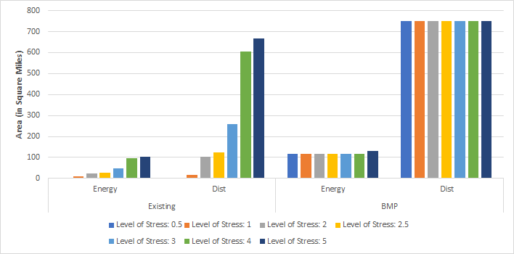

Currently only one high school, Thomas S Wootton, is accessible at the none level of stress (LTS .5) using the energy consumption method. All high schools are accessible using the distance method, but their total area constitutes less than one square mile. In fact, it is only at the low level of stress (LTS 2 or less) that every school becomes traversable with both methods (Figure 4). Even then, 24% of the 25 high schools have extremely small bikesheds; for example, Paint Branch High School’s distance method - the larger of its two bikesheds - has an area of .01 square miles. Each of the six schools (Damascus, Seneca Valley, Quince Orchard, Gaithersburg, Walter Johnson, and Paint Branch) with extremely low accessibility is located on street segments with moderate high or higher LTS values (equal to 4 or higher) and with limited or no biking infrastructure. Those same six schools do not see any significant improvement in accessibility until the LTS is raised to the moderate high level, at which some schools still have limited accessibility in a bikeshed obtained in the energy consumption method. This isolation of energy consumption bikesheds contrasts with the connectivity of the distance consumption bikesheds.
Figure 4: Difference in Energy Consumption and Distance Methods at a Low Level of
Stress Using Existing Infrastructure

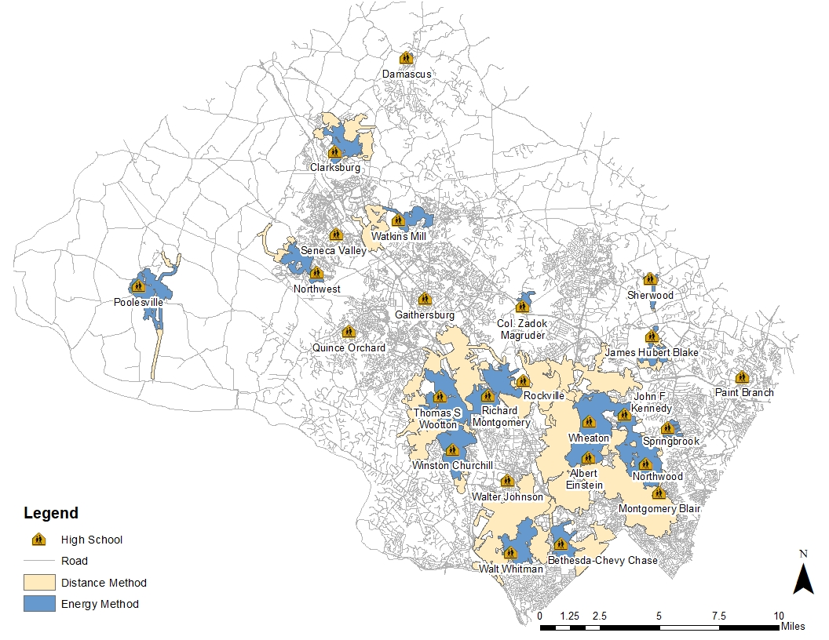

Table 2 compares the sizes of bikeshed obtained in 28 scenarios, depending on the assumed LTS (7) and distance/energy method used (2), and shows bikeshed area and percentage changes from current conditions to the planned state (2). The planned infrastructure would increase energy consumption model accessible square miles by 1,590% and distance model accessible square miles by 817% at the none level of stress (LTS .5). Rates of improvement are highest at the lower LTSs, reinforcing the findings from the metro station bikeshed analysis. The significant increase in accessible square miles supports the metro analysis conclusion that improvements were well planned and indicates that one of the most significant barriers to current accessibility is lack of appropriate infrastructure. The smaller gains at higher levels of stress coincide with the county’s stated intent to minimize travel along higher-stress streets. The large gains at lower levels of stress illustrate the county’s ability to successfully identify network gaps and increase connectivity between activity hubs.
Table 2: Change in Bikeshed Area From Existing to Planned Infrastructure by Percentage and Square Mileage
 | Percent Gain |  | Area Gain |  | Existing Total Area |  | BMP Total Area
 | Energy | Distance | Energy | Distance | Energy | Distance | Energy | Distance
Level of Stress: .5 | + 1,590% | + 817% | +116.16 mi² | +750.00 mi² | 0.07 mi² | 0.91 mi² | 116.23 mi² | 750.91 mi²
Level of Stress: 1 | + 9% | + 41% | +105.12 mi² | +732.97 mi² | 11.11 mi² | 17.95 mi² | 116.23 mi² | 750.91 mi²
Level of Stress: 2 | + 4% | + 6% | +91.08 mi² | +647.15 mi² | 25.15 mi² | 103.77 mi² | 116.23 mi² | 750.91 mi²
Level of Stress: 2.5 | + 3% | + 5% | +88.48 mi² | +625.44 mi² | 27.75 mi² | 125.48 mi² | 116.23 mi² | 750.91 mi²
Level of Stress: 3 | + 1% | + 2% | +67.69 mi² | +492.61 mi² | 48.54 mi² | 258.30 mi² | 116.23 mi² | 750.91 mi²
Level of Stress: 4 | + .2% | + .2% | +18.32 mi² | +147.00 mi² | 97.91 mi² | 603.91 mi² | 116.23 mi² | 750.91 mi²
Level of Stress: 5 | + .3 % | + .1% | +28.56 mi² | +85.09 mi² | 103.87 mi² | 665.83 mi² | 132.43 mi² | 750.91 mi²

5. Concluding Remarks

A bicycle accessibility analysis based on the combination of the LTS and energy consumption methods takes into account important external conditions that influence people’s bike trips, and provides a more realistic conceptualization of bike accessibility to transportation planners than without such considerations.

The findings demonstrate that the distance-based method overstates the accessibility of metro stations and public high schools. Although the inclusion of LTS method reflects bicyclists’ perceptions of safety, inclusion of the energy consumption method allows for consideration of perceptions of difficulty as well. The latter illustrates that, when also accounting for current infrastructure’s LTS, there are many metro stations and high schools that are either inaccessible at certain levels of stress or have limited accessibility.

The analysis results established that, despite current lack of accessibility, the improvements proposed in the Bicycle Master Plan are well designed to increase bicycling catchment areas of all metro stations and high schools. Improvements along major routes and around destinations are well targeted to make biking an easier and more attractive opportunity for riders with a wider range of stress tolerance.

Notwithstanding, our findings indicate that the energy method is instructive when examining specific sites. For example, planned infrastructure improves some schools’ distance method connectivity dramatically but not energy consumption connectivity. Planned infrastructure for destinations with a higher variability in elevation benefits from consideration of energy consumption method. There is more isolation between bikesheds created with the energy consumption method than with the distance method, even when accounting for planned infrastructure. Examining areas using the energy method will better enable planners to determine where future bicycle infrastructure will have the greatest impact by allowing them to isolate the impact of individual improvements.

Assumptions made in this study’s proposed model are based on the average adult and likely overestimate the bikeshed for younger bicyclists. Reducing the 80kg weight assumed for an adult rider to 40 or 50kg for a child and adjusting the 4.4 mile and 50,000 Joule limits for younger riders should be tested, particularly for destinations frequented by younger populations. Changing the catchment area limit must also be reduced as the mass of the rider is changed, since a smaller mass corresponds to less energy consumption. Our model could also be extended to include travel demand within catchment areas based on different rider profiles with varied energy limits.

Incorporating energy consumption adds another layer of complexity to existing LTS calculation methods. The resulting method offers a more nuanced view of bikeability by demonstrating the impact of elevation on accessibility, which allows planners to better quantify the impact of bicycle infrastructure. Using stress level restrictions as scenarios, planners can evaluate the impact of bicycle improvements with greater precision.

Acknowledgements

The authors thank Russell Provost (Montgomery County Planning) for assistance in data acquisition and local knowledge.

Division of Work and Credit Among Authors

Devin McNally and Rachel Tillinghast share tasks of collecting and processing data, conducting analyses, and writing the paper. Hiroyuki Iseki is responsible for the overall concept of the study, oversight of development and implementation of the presented method, and preparation of the paper.

References

Cervero, R., Duncan, M., 2006. Which Reduces Vehicle Travel More: Jobs Housing Balance or Retail-Housing Mixing? The Journal of American Planning Association 475–490.
Cervero, R., Duncan, M., 2003. Walking, Bicycling, and Urban Landscapes: Evidence From the San Francisco Bay Area. American Journal of Public Health.
Daniel, P., Burns, L., 2018. How steep is that street? Mapping ‘real’ pedestrian catchments by adding elevation to street networks. Radical Statistics 121, 26–48.
Dill, J., Carr, T., n.d. Factors Affecting Bicycle Demand: Initial Survey Findings from the Portland, Oregon Region. Transportation Research Record: Journal of the Transportation Research Board 2031, 9–17.
Dill, J., Gliebe, J., 2008. Understanding and Measuring Bicycling Behavior: A Focus on Travel Time and Route Choice. Portland State University Urban Studies and Planning Faculty Publications and Presentations.
Education Group, 2019. High Schools. URL http://data-mcgov-gis.opendata.arcgis.com/datasets/9e1d7e774f764303b845f73815d16298_0. Accessed April 15, 2019.
Foster, N.M.-A., 2014. Predicting Bicyclist Comfort in Protected Bike Lanes. Portland State University Dissertations and Theses.
Foster, N., Monsere, C.M., Dill, J., Clifton, K., 2015. Level-of-Service Model for Protected Bike Lanes. Transportation Research Record 2520, 90–99.
Geller, R., Igarta, D., Birk, M., Rose, M., 2008. Cycle Zone Analysis (CZA): A New Bicycle Transportation Planning Tool.
Greenstein, A.S., 2015. Mapping Bikeability: A Spatial Analysis on Current and Potential Bikeability in Austin, Texas. University of Texas at Austin Master’s Thesis.
Griffen, G.P., Sener, I.N., 2016. Planning for Bike Share Connectivity to Rail Transit. Journal of Public Transportation 19.
Iseki, H., Tingstrom, M., 2014. A New Approach in the Bikeshed Analysis with Consideration of Topography, Street Connectivity, and Energy Consumption. Computers, Environment, and Urban Systems 48, 166–177.
Jensen, S.U., 2007. Pedestrian and Bicyclist Level of Service on Roadway Segments. Transportation Research Record: Journal of the Transportation Research Board 43–51.
Lowry, M.B., Hadden-Loh, T., Furth, P., 2016. Prioritizing New Bicycle Facilities to Improve Low-Stress Network Connectivity. Transportation Research 86, 124–140.
Macias, K., 2016. Alternative Methods for the Calculation of Pedestrian Catchment Areas for Public Transit. Transportation Research Record: Journal of the Transportation Research Board 138–144.
Maryland-National Park and Planning Commission: Montgomery County, 2018a. Montgomery County Bicycle Master Plan.
Maryland-National Park and Planning Commission: Montgomery County, 2018b. Appendix C, in: Bicycle Master Plan.
Maryland-National Park and Planning Commission: Montgomery County, 2018b. Appendix D, in: Bicycle Master Plan.
Mekuria, M.C., Furth, P.G., Nixon, H., 2012. Low-stress bicycling and network connectivity. Mineta Transportation Institute Publications.
Montgomery County Government, 2019. dataMontgomery. URL https://data.montgomerycountymd.gov . Accessed April 23, 2019.
Montgomery County Planning, 2019. Bicycle Stress Map. URL https://montgomeryplanning.org/resources/bicycle-stress-map/. Accessed May 15, 2019.
Necessary, M., 2016. Developing an Infrastructure-Informed Indexes for Pedestrians and Bicyclists. Center for Transportation Research.
Okon, I., Burssel, M.J., Van Den Bosch, F.H.M., Moreno, C.A., Van Maarseveen, M.F.A.M., 2017. A Statistical Approach to the Estimation of Bicycle Level of Service Models for the Cicloruta in Bogota, Colombia. WIT Transactions on the Built Environment 176.
Parast, A.B., 2010. Bikeability Analysis: Portland and Seattle. Seattle Transit Blog. URL https://seattletransitblog.com/2010/04/20/portland-and-seattle-bicycle-analysis/
Recreation Group, 2019. Bikeshare Stations. URL http://data-mcgov-gis.opendata.arcgis.com/datasets/64c13a3e53614145ade1d39fae2044a3_0. Accessed April 10, 2019.
Reilly, M., Landis, J., 2002. The Influence of Built Form and Land Use on Mode Choice: Evidence from the 1996 Bay Area Travel Survey (No. IURD WP 2002-4(1)). The Influence of Built Form and Land Use on Mode Choice: Evidence from the 1996 Bay Area Travel Survey.
Scott, D.M., Ciuro, C., n.d. What factors influence bike share ridership? An investigation of Hamilton, Ontario’s bike share hubs. Travel Behaviour and Society 16, 50–58.
Transportation Group, 2019. Purple Line Stops. URL http://data-mcgov-gis.opendata.arcgis.com/datasets/4145151c38fd4642a0129d03a43b71ea_0. Accessed April 20th, 2019
Transportation Group, 2019.. METRO Stations. URL http://data-mcgov-gis.opendata.arcgis.com/datasets/712c893b4f064506a905ede8d438c66d_0. Accessed April 20th, 2019
United States Geological Survey, n.d. 1x1 degree ArcGrid 2019; ⅓ arc-second digital elevation model. National Elevation Dataset. URL https://viewer.nationalmap.gov/basic/. Accessed April 10th, 2019
Wang, H., Palm, M., Chen, C., Vogt, R., Wang, Y., 2016. Does bicycle network level of traffic stress (LTS) explain bicycle travel behavior? Mixed results from an Oregon case study. Journal of Transport Geography 57, 8–18.
Wang, H., Vogt, R., Palm, M., 2015. Geospatial Analysis of Bicycle Network “Level of Traffic Stress”, Bicycle Mode Choice Behavior, and Bicycle Crashes for Risk Factor Identification (No. 2013- S- OSU- 0035). Pacific Northwest Transportation Consortium.
Winters, M., Cooper, A., 2008. What Makes a Neighbourhood Bikeable: Reporting on the Results of Focus Group Sessions. Translink and the University of British Columbia.

